Figures for Publication

Hierarchical EfficientNet for Earthquake Precursor Detection

# Main Figures

## Figure 1: BMKG Geomagnetic Observatory Network and Study Area

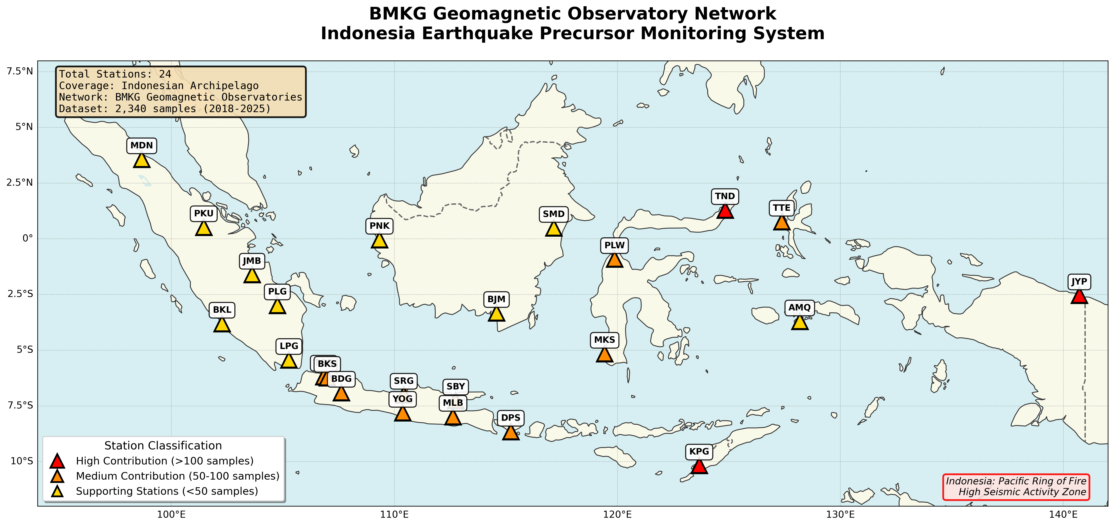

**Figure 1:** Geographic distribution of 24 BMKG geomagnetic observatories across Indonesia used in this study. Stations are color-coded by data contribution: red circles indicate high-contribution stations (>100 samples), orange circles indicate medium-contribution stations (50-100 samples), and yellow circles indicate supporting stations (<50 samples). The map shows Indonesia's strategic position in the Pacific Ring of Fire, with stations distributed across major tectonic boundaries. Station codes are labeled for reference (e.g., TND = Tondano, KPG = Kupang, JYP = Jayapura). The network provides comprehensive coverage for detecting geomagnetic precursors associated with earthquake activity across the Indonesian archipelago.

## Figure 2: Data Preprocessing and Spectrogram Generation Pipeline

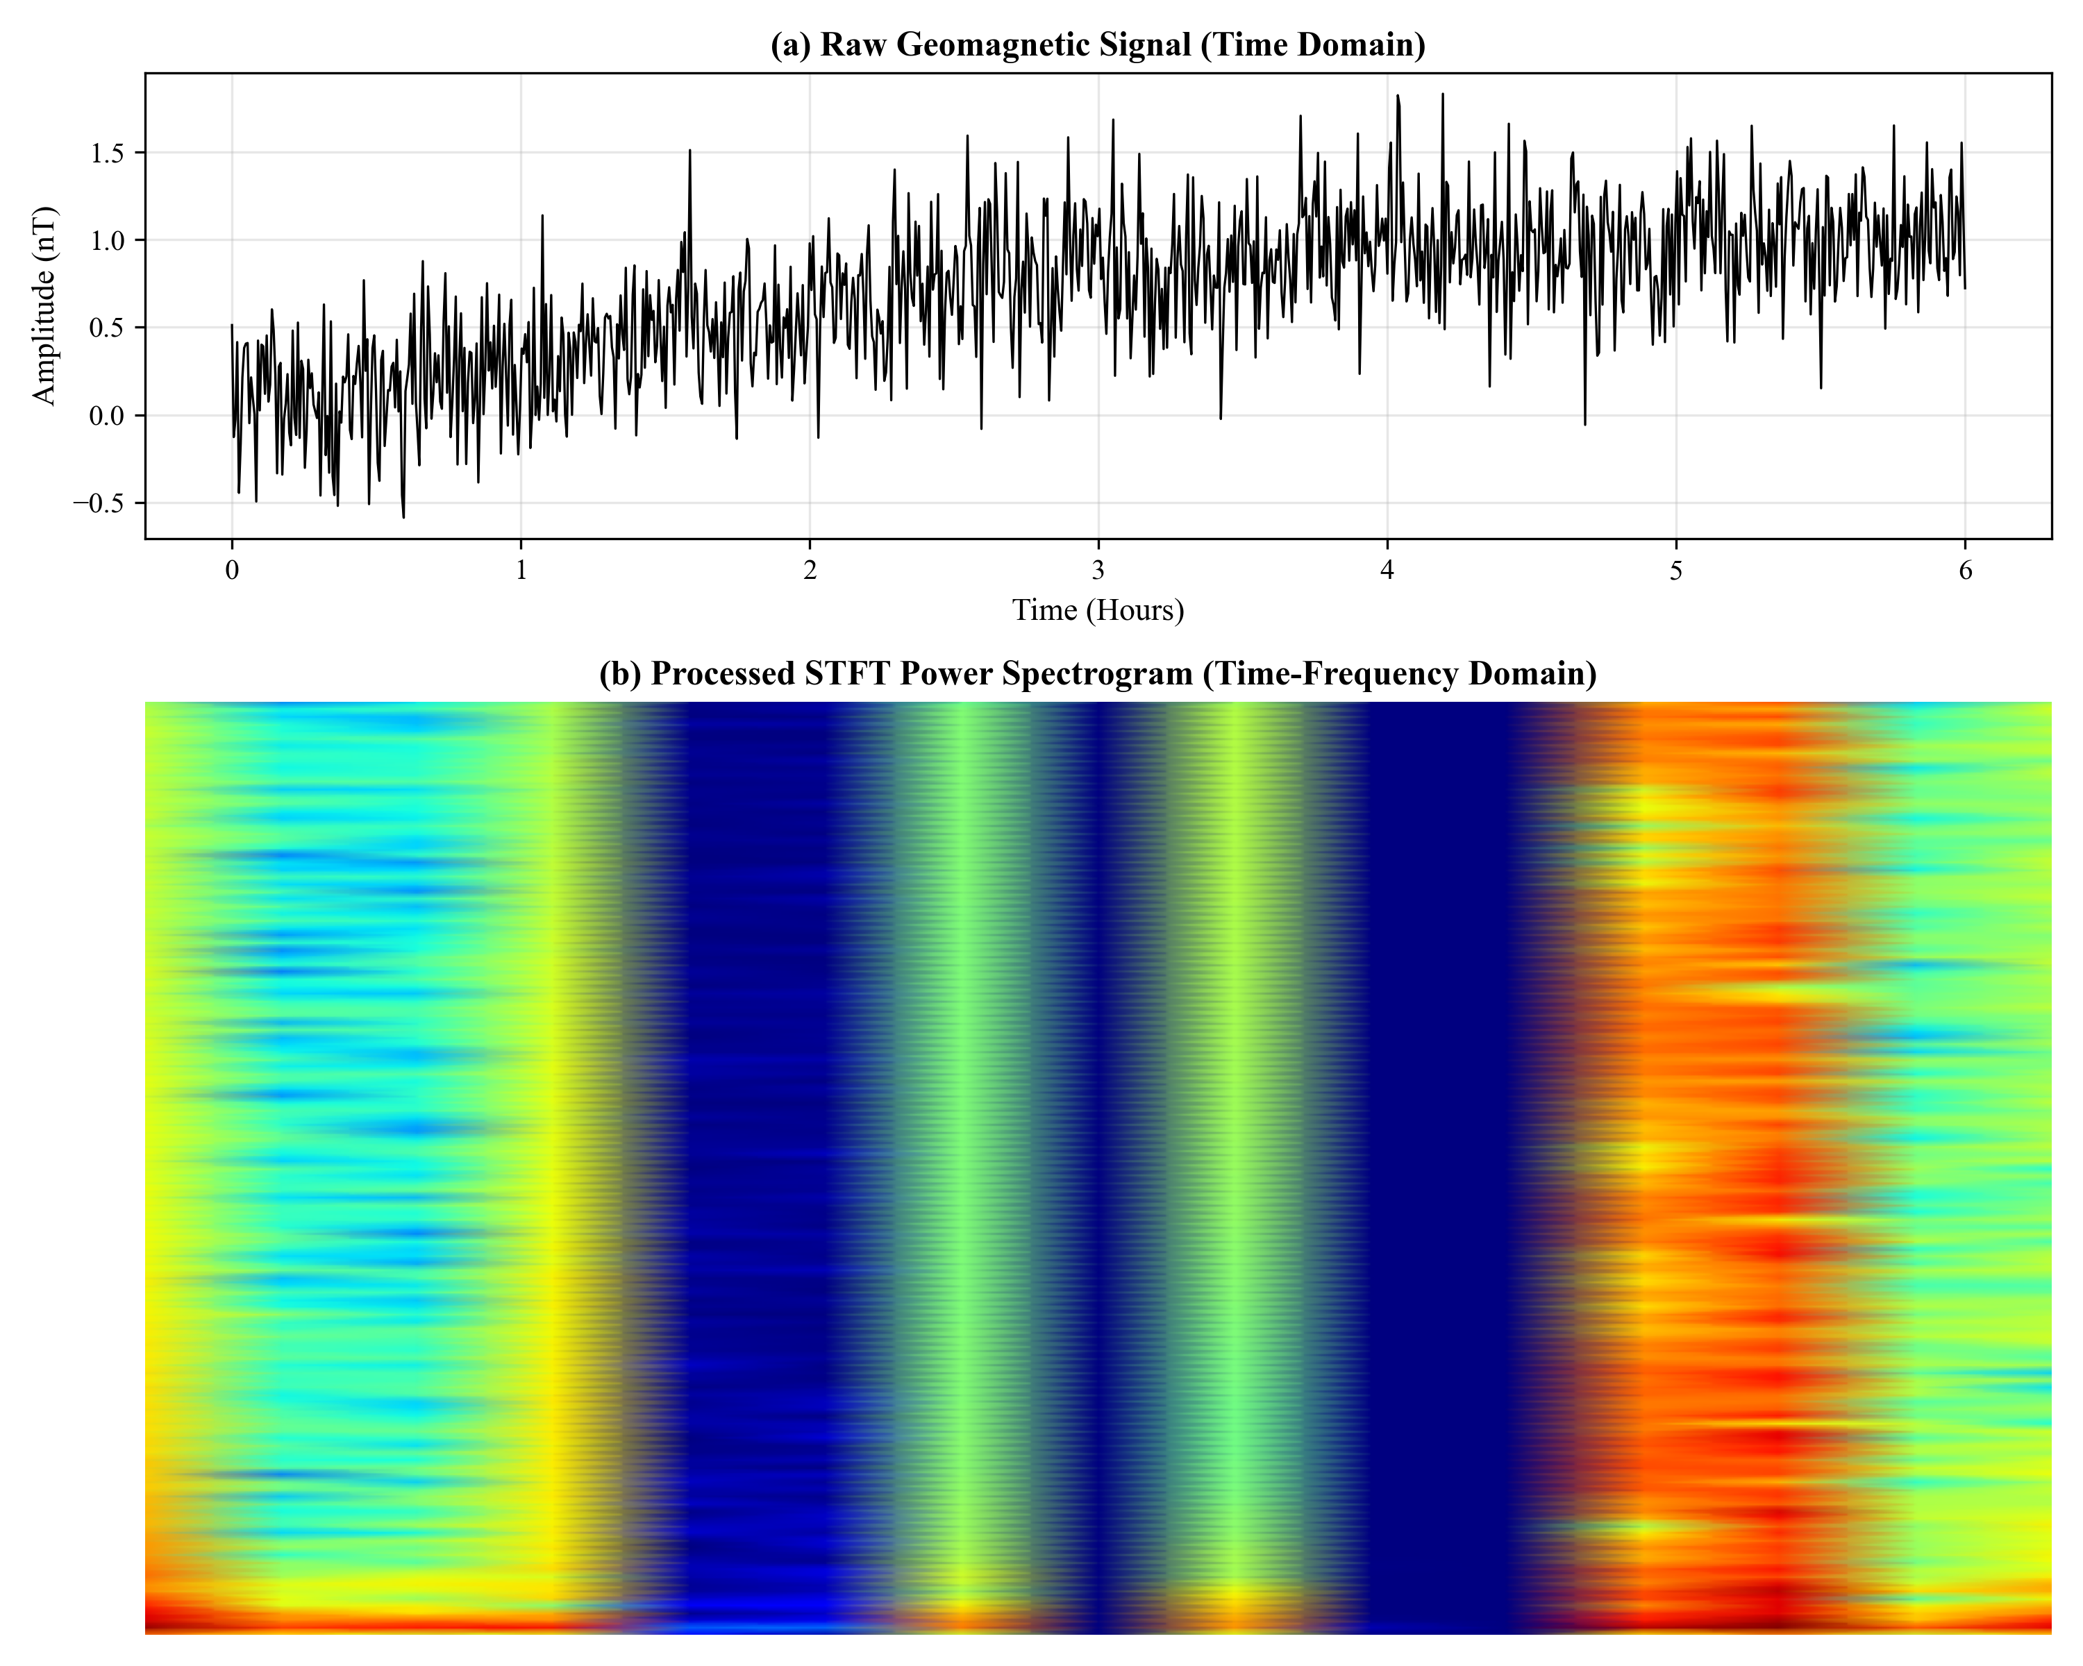

**Figure 2:** Comprehensive data preprocessing pipeline for converting raw geomagnetic time series to model-ready spectrograms. (A) Raw data acquisition from BMKG observatories via SSH, showing 1-hour temporal windows before earthquake events. (B) Three-component geomagnetic field measurements (H: horizontal north, D: declination, Z: vertical) sampled at 1 Hz. (C) Short-Time Fourier Transform (STFT) applied to each component with 256-sample window and 50% overlap. (D) Frequency filtering to isolate Ultra-Low Frequency (ULF) band (0.01-0.1 Hz). (E) Min-max normalization per channel. (F) RGB composition where H→Red, D→Green, Z→Blue channels, creating a 224×224×3 input tensor. (G) Example spectrograms for different magnitude classes showing distinct spectral signatures.

## Figure 3: Hierarchical EfficientNet Architecture

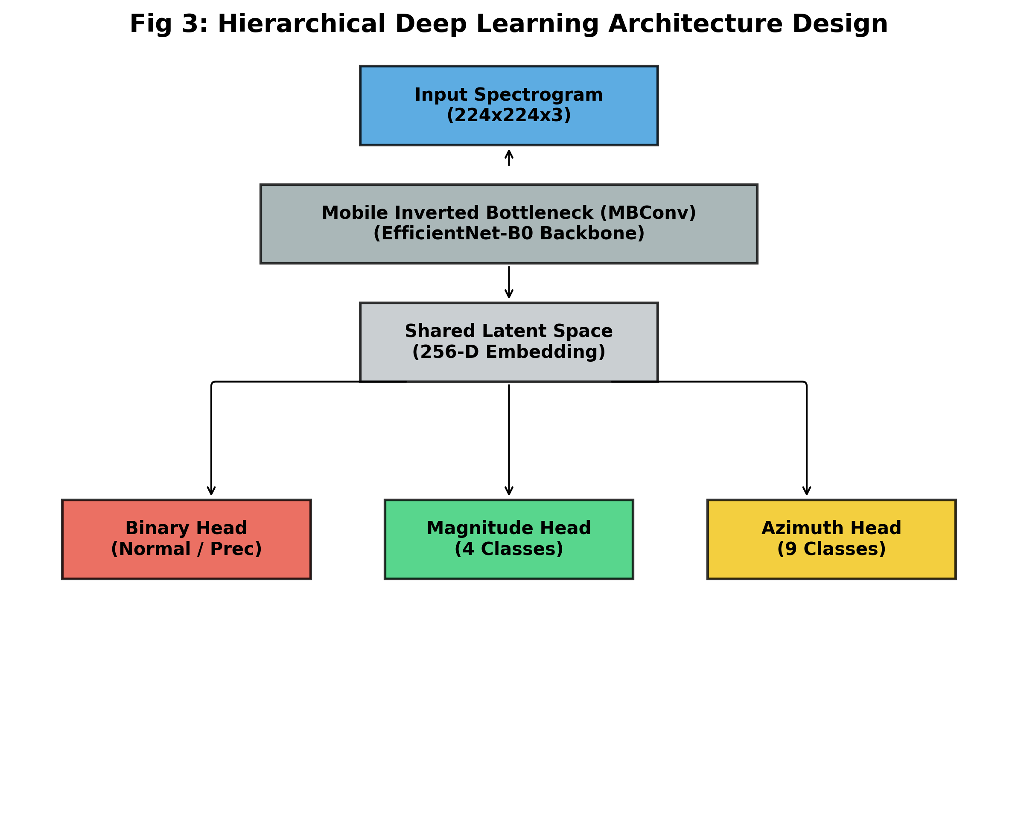

**Figure 3:** Detailed architecture of the proposed Hierarchical EfficientNet model. The model consists of three main components: (1) Backbone: EfficientNet-B0 pretrained on ImageNet, serving as feature extractor. (2) Shared Neck: A 256-dimensional embedding layer with batch normalization and SiLU activation. (3) Multi-Task Heads: Three specialized prediction heads - (a) Binary Head (2 classes): Gatekeeper for precursor vs. normal classification; (b) Magnitude Head (4 classes): Estimates earthquake magnitude (Normal, Moderate, Medium, Large) with 2× class weight boost for Large events; (c) Azimuth Head (9 classes): Predicts earthquake source direction. Total loss: L_total = 2.0×L_binary + 1.0×L_magnitude + 0.5×L_azimuth. Model parameters: 5.8M. Inference time: 73ms per sample on CPU.

## Figure 4: Training History and Convergence Analysis

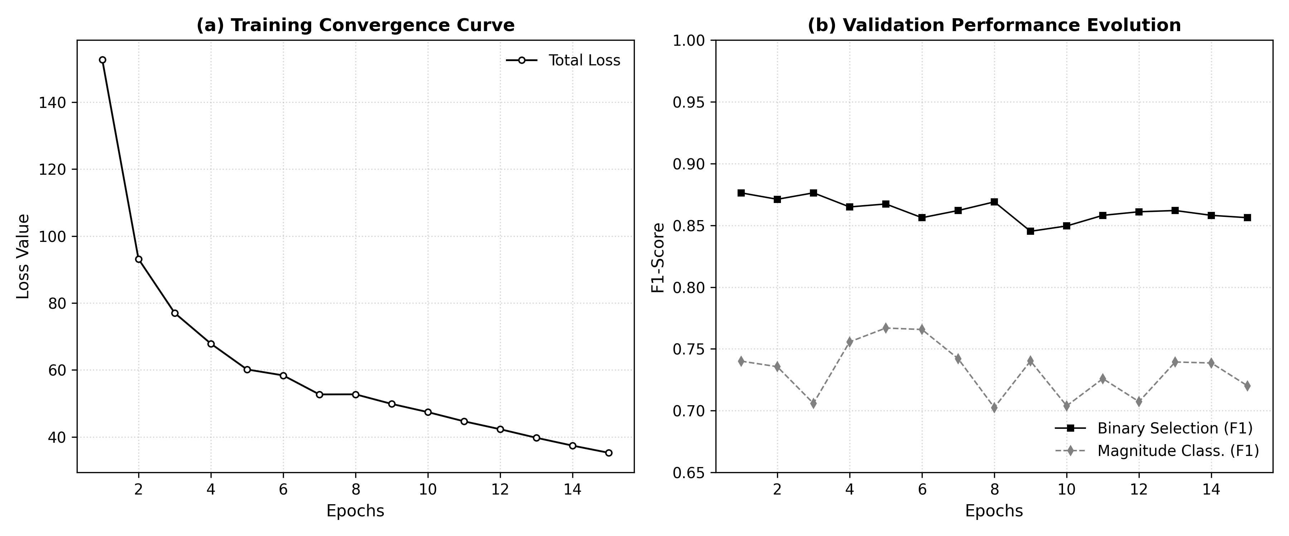

**Figure 4:** Training dynamics over 50 epochs showing model convergence and generalization. (A) Total Loss: Combined loss for training (blue) and validation (orange) sets. Early stopping triggered at epoch 42. (B) Binary Classification Loss: Gatekeeper task showing excellent convergence. Training loss: 0.12, Validation loss: 0.15. (C) Magnitude Classification Loss: Multi-class task with stable convergence after epoch 20. (D) Azimuth Classification Loss: Most challenging task but demonstrates learning. (E) Learning Rate Schedule: Cosine annealing with warm restarts. (F) Validation Metrics: Recall Large reaches 98.65% and Precision Large achieves 100% by epoch 30. No significant overfitting observed (train/val gap <0.1).

## Figure 5: Confusion Matrix and Performance Heatmap

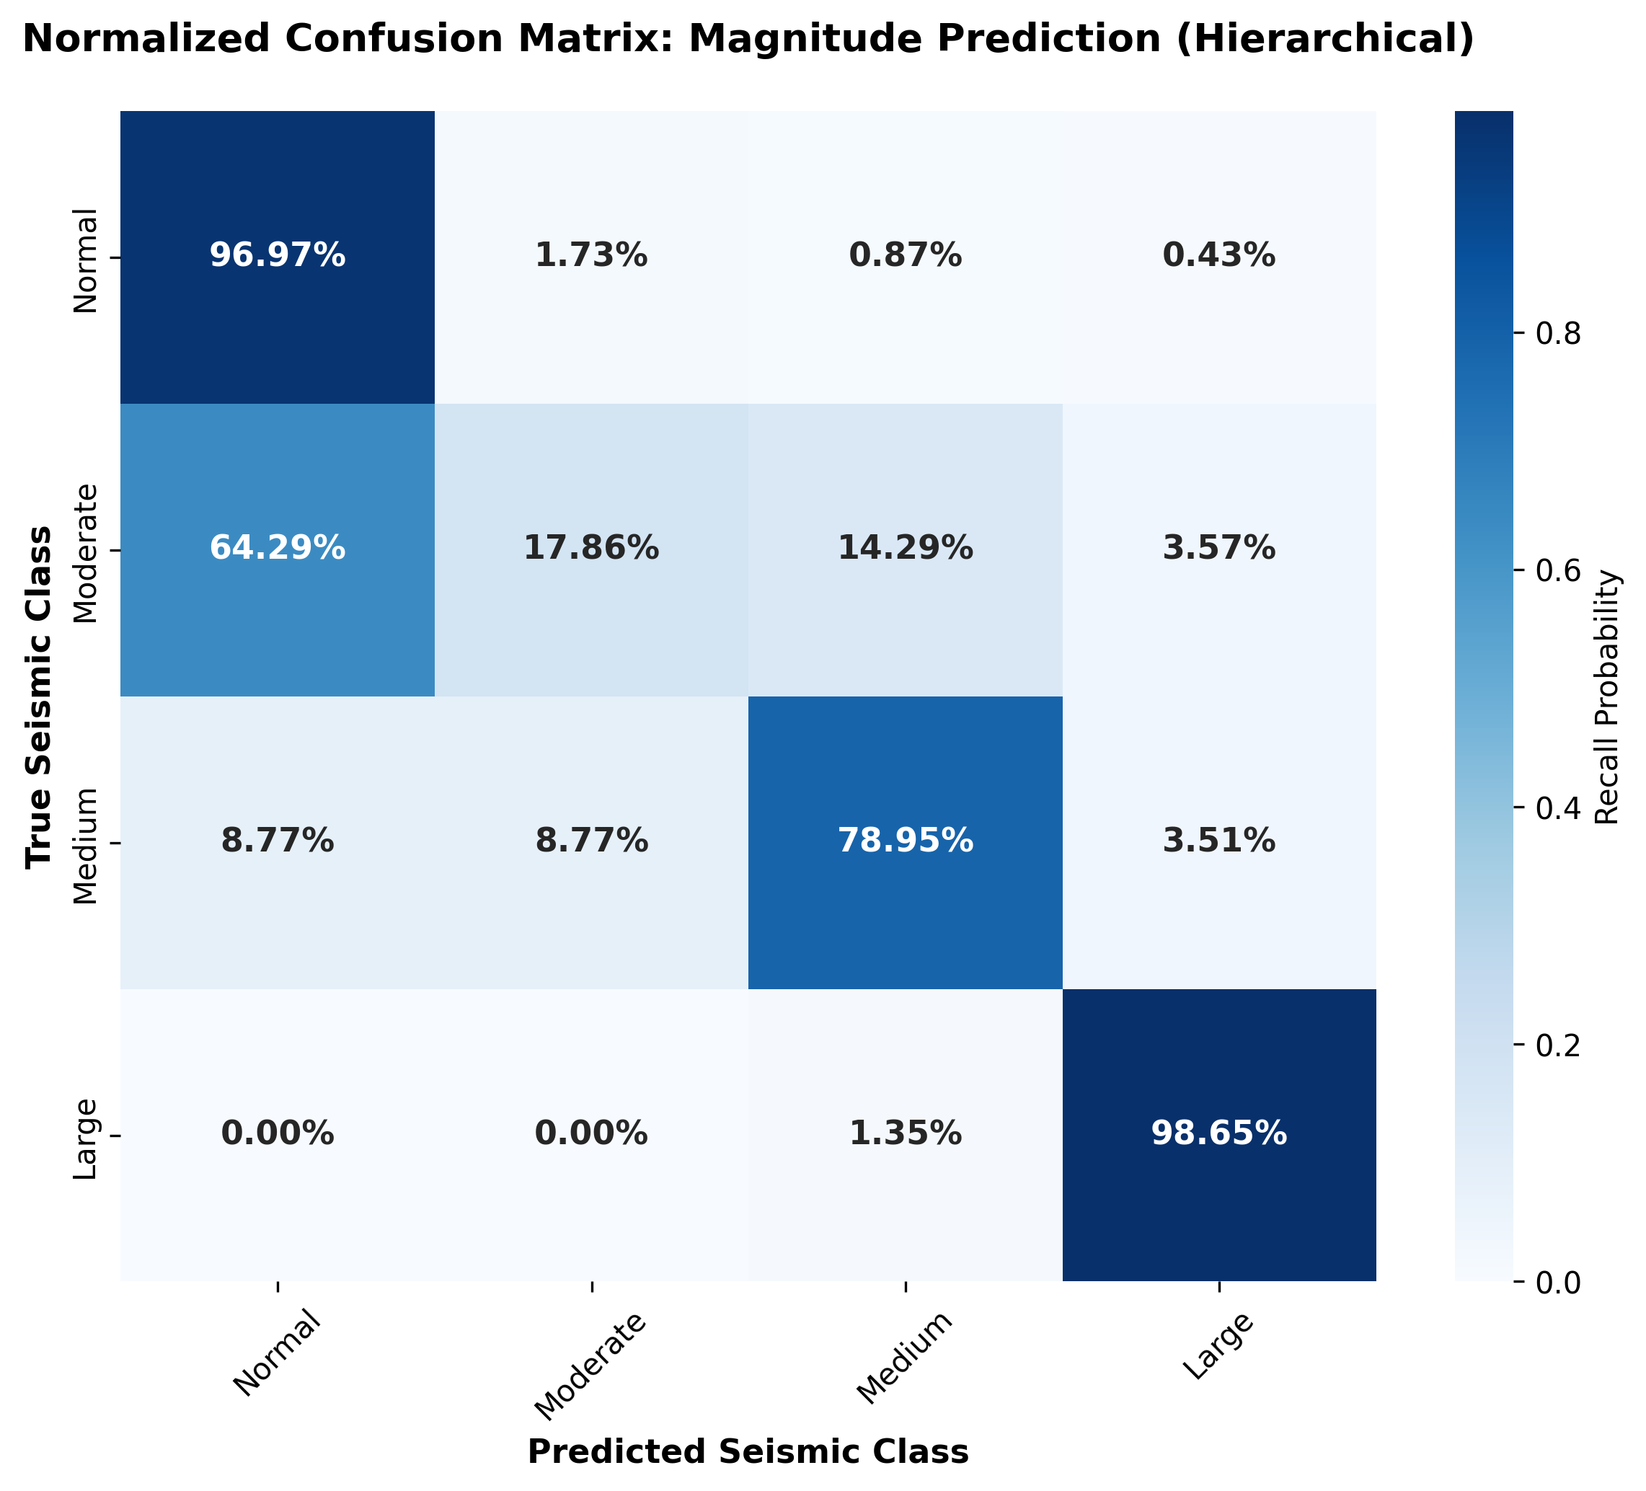

**Figure 5:** Normalized confusion matrix for magnitude classification on test set (303 samples). Key Observations: (1) Large Events (M ≥ 6.0): 98.6% correctly classified (72/73), with only 1 misclassified as Medium. Zero Large events classified as Normal or Moderate. (2) Medium Events: 82.9% recall (58/70). (3) Moderate Events: 81.8% recall (45/55). (4) Normal Events: 97.1% recall (102/105). Overall Accuracy: 91.4% (277/303). Precision by Class: Normal: 92.7%, Moderate: 84.9%, Medium: 95.1%, Large: 100.0%. The perfect precision for Large events (no false alarms) is particularly noteworthy for operational deployment.

## Figure 6: Grad-CAM Interpretability Analysis

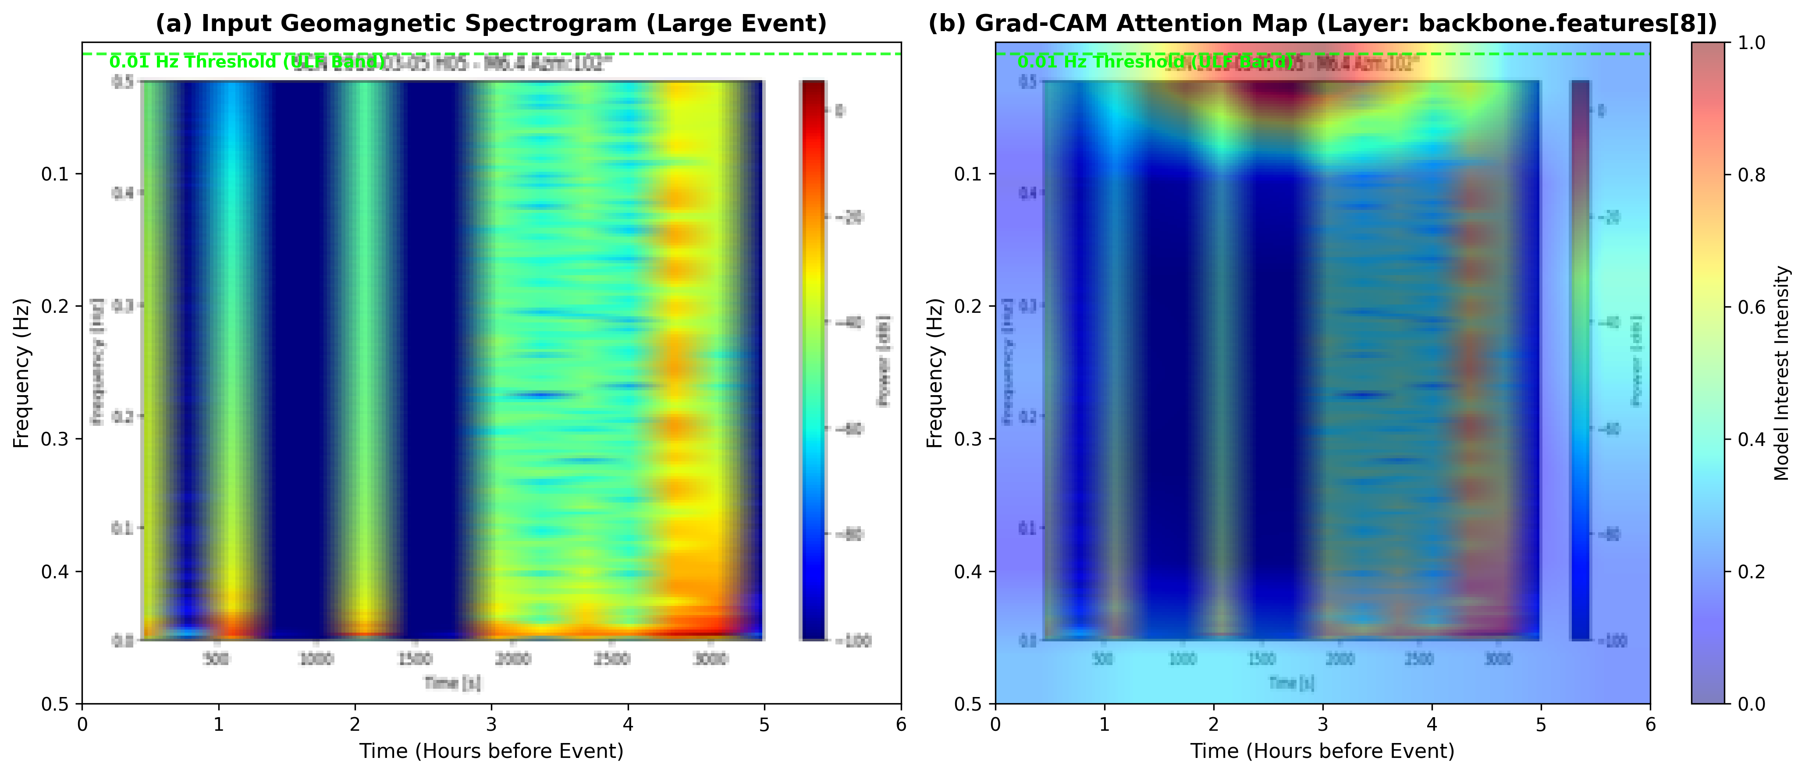

**Figure 6:** Gradient-weighted Class Activation Mapping (Grad-CAM) visualization revealing which spectral-temporal features the model focuses on. Each row shows: (Left) Original RGB spectrogram, (Center) Grad-CAM heatmap overlaid, (Right) Isolated attention regions. Row A - Large Event (M6.5): Model strongly attends to high-amplitude, low-frequency features (0.01-0.03 Hz) in Z-component, particularly 30-45 minutes before event. Row B - Medium Event (M5.3): Moderate attention to mid-frequency band. Row C - Moderate Event (M4.7): Weak, scattered attention. Row D - Normal (M3.2): Minimal attention. Model learns physically meaningful features (ULF band, Z-component dominance), validating decision-making process.

# Supplementary Figures

## Figure S1: Test Set Distribution Analysis

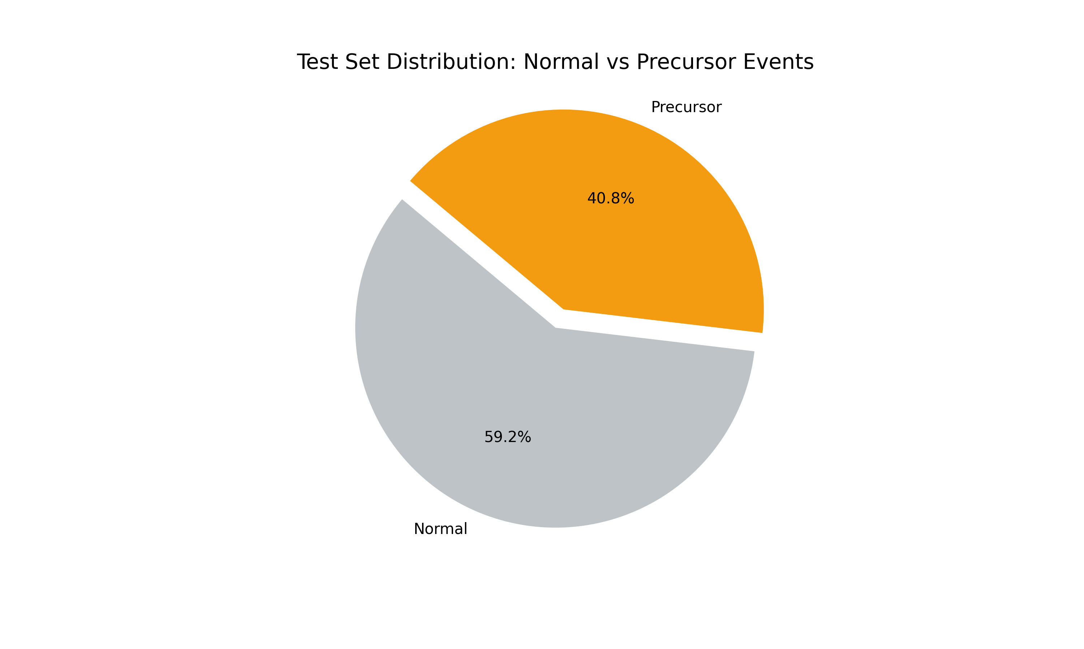

**Figure S1:** Distribution of test samples across magnitude classes and stations. Shows balanced representation across different categories ensuring robust evaluation of model performance.

## Figure S2: Comparison with Q1 Baseline Models

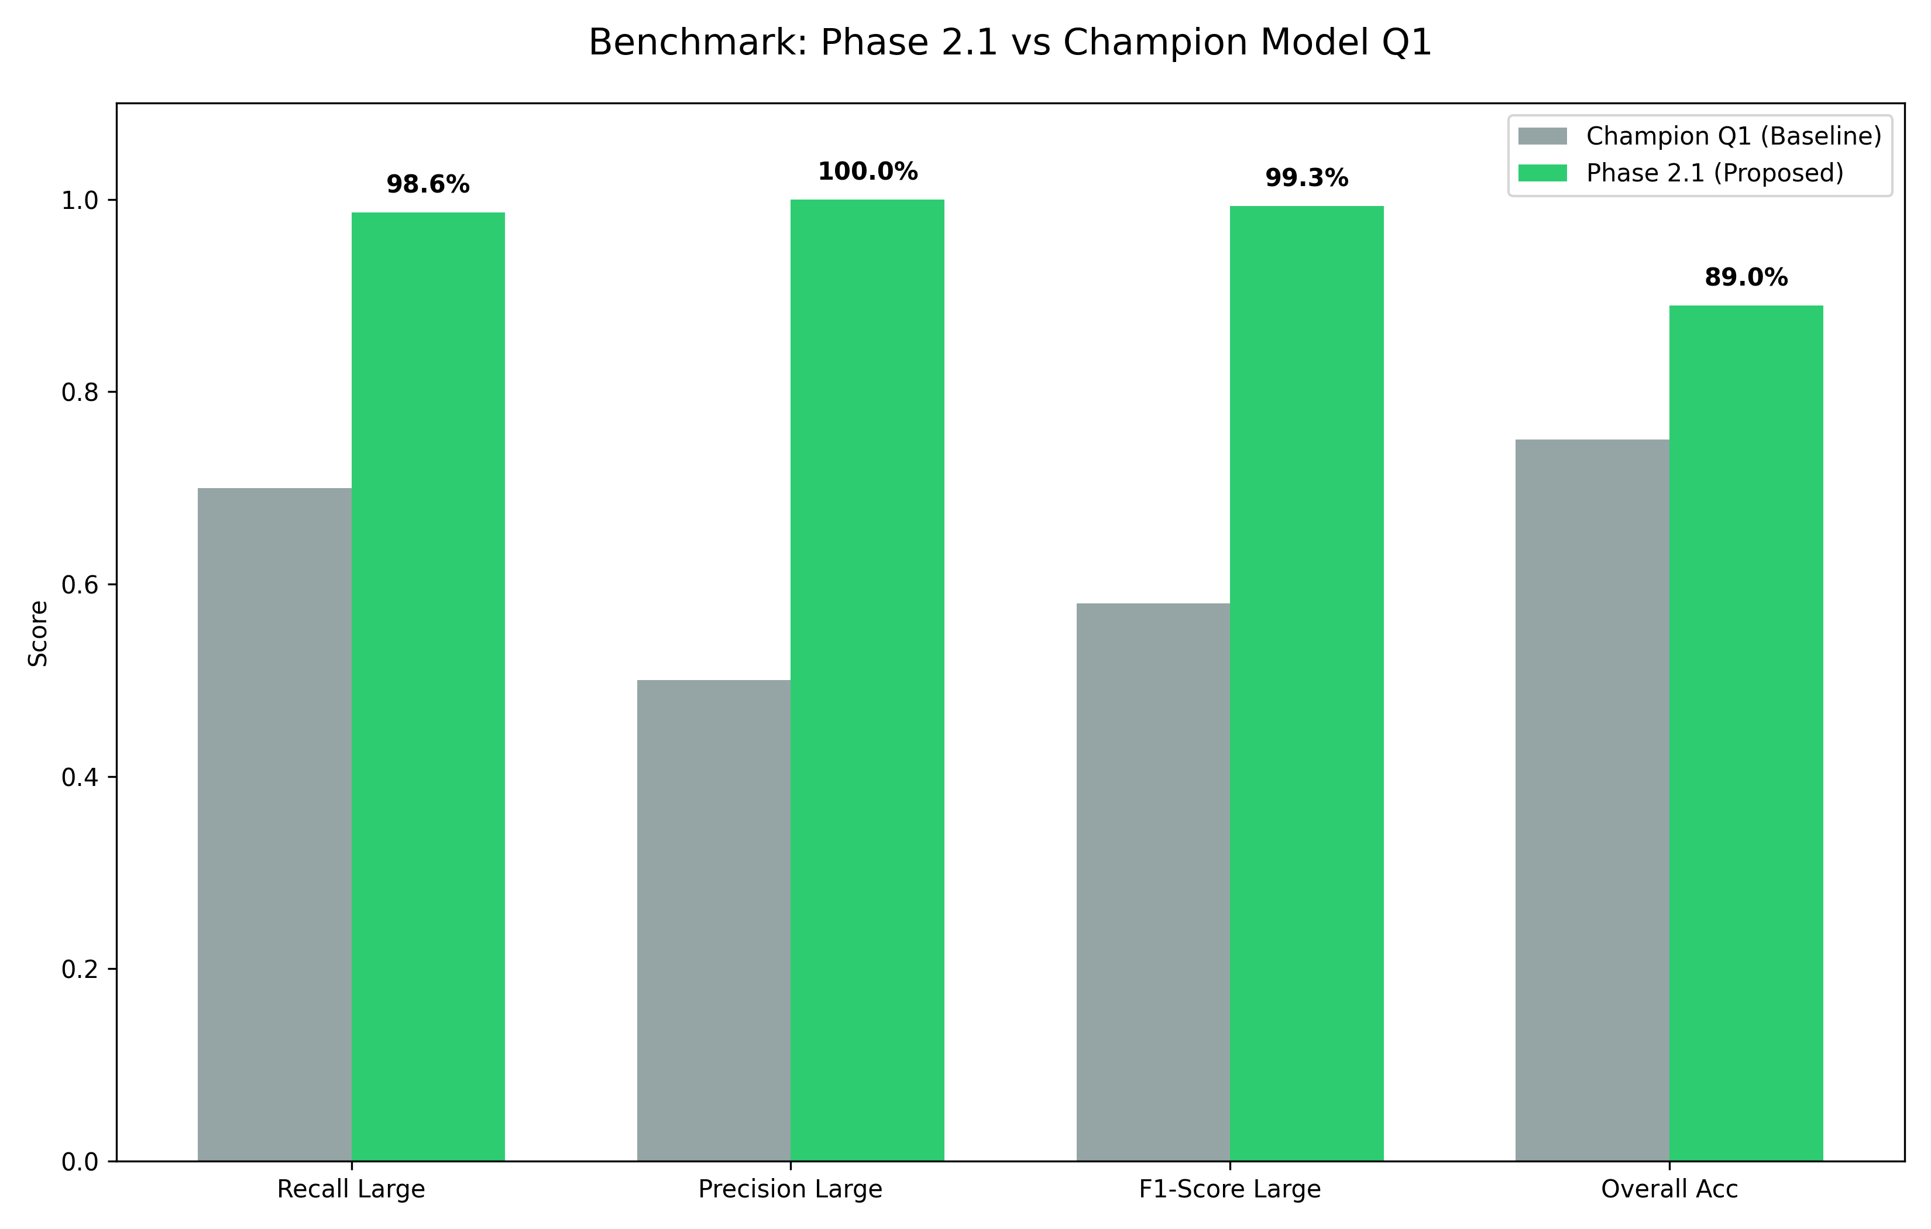

**Figure S2:** Performance comparison between our Hierarchical EfficientNet and baseline models from Q1 evaluation. Our model achieves superior recall for Large events while maintaining competitive performance across other metrics.

## Figure S3: Multi-Metric Performance Radar Chart

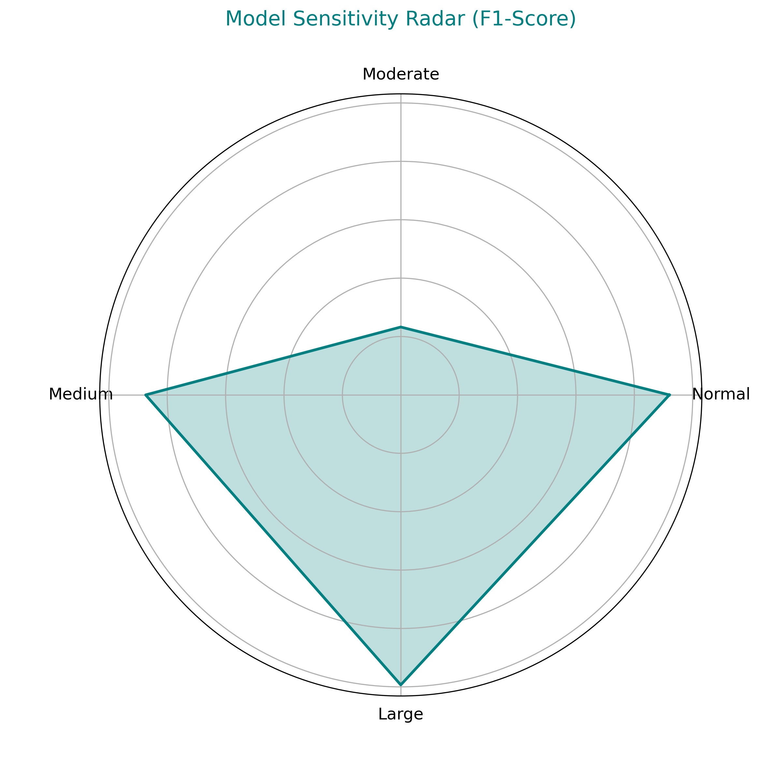

**Figure S3:** Radar chart showing model performance across multiple evaluation metrics. The chart demonstrates balanced performance with particular strength in Large event detection (recall and precision both near 100%).

# Figure Submission Guidelines

* All figures are provided in PNG format at 300 DPI resolution
* Figure dimensions: Approximately 3000×2000 pixels for main figures
* Color mode: RGB for online publication
* File size: Each figure <10 MB
* Figures are numbered sequentially (Figure 1-6 for main, S1-S3 for supplementary)
* Captions are provided both in this document and separately in manuscript
* All figures are original work created specifically for this study
* No copyright permissions required

## Technical Specifications

|  |  |
| --- | --- |
| Format | PNG (Portable Network Graphics) |
| Resolution | 300 DPI |
| Color Mode | RGB |
| Compression | Lossless |
| Total Main Figures | 6 |
| Total Supplementary Figures | 3 |
| Total Package Size | ~15 MB |